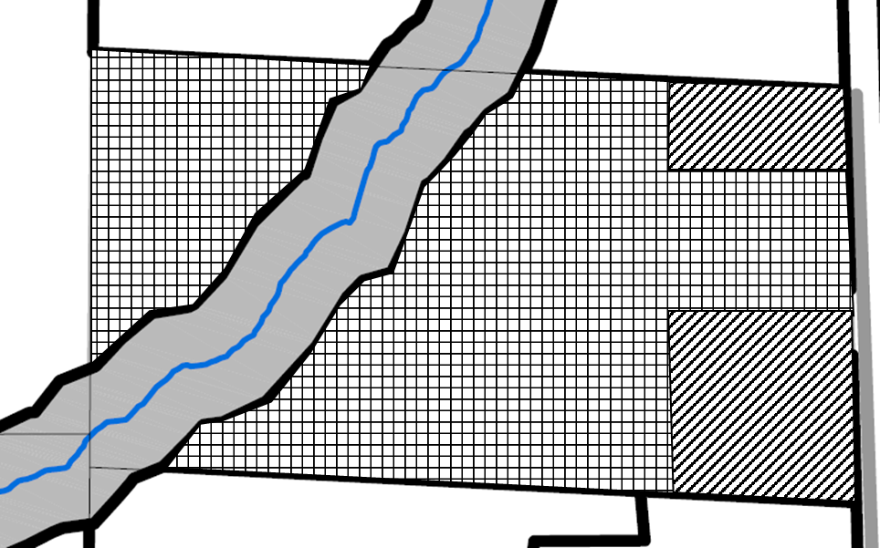

Environmental Conservation (EC) Zone
Rural Residential (RR) Zone
Rural 260 (RU-260) Zone
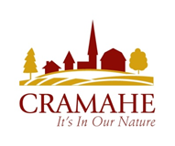
Subject Property
Concession 6, Part Lot 25,
RP 38R1540; Part 1
Township of Cramahe
File No. D14-ELL-09-25
Schedule A to By-law No. 2025-48
Passed this 22nd day of July, 2025
______________________________
Mayor
_____________________________
Clerk

